**BUSINESS DECISION MODELING**

Team Assignment 1 (Bob’s Retirement Planning)

**Team 5 (Evening Class)**

Ankitkumar Borkhataria

Ajay Muthukrishnan

Ieshika Chandra

Kokila Dular

Kunja Dutta

Meghana Kasula

Reena Malipatil

1. **Develop a Base case scenario.**

The base case scenario is calculated in the attached excel sheet.

1. **Create a *Tornado Chart* showing the sensitivity of Bob’s age at which retirement savings run out (Call this Bob’s zero-asset age) versus the various input parameters. Vary each input parameter with +/- 10%.**

Ans: Below is the screenshot of the tornado chart showing sensitivity of Bob’s age at which his retirement savings run out by varying the various input parameters by 10%.

­­­­­­ 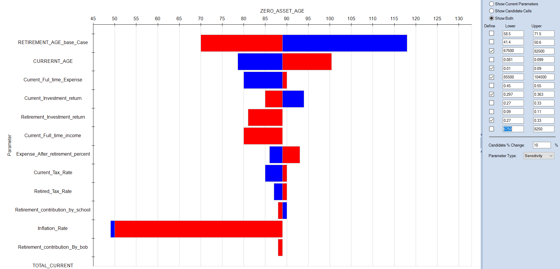

1. **What are the *minimum additional savings* (currently $7,500, all before tax)Bob needs to contribute such that Bob’s retirement assets do not run out before age 90?**

Ans: By doing What If-> Goal-Seek analysis, the minimum additional saving that Bob can do such that he does not run out of assets before 90 years is $9900. Below is screenshot shows what-if analysis.

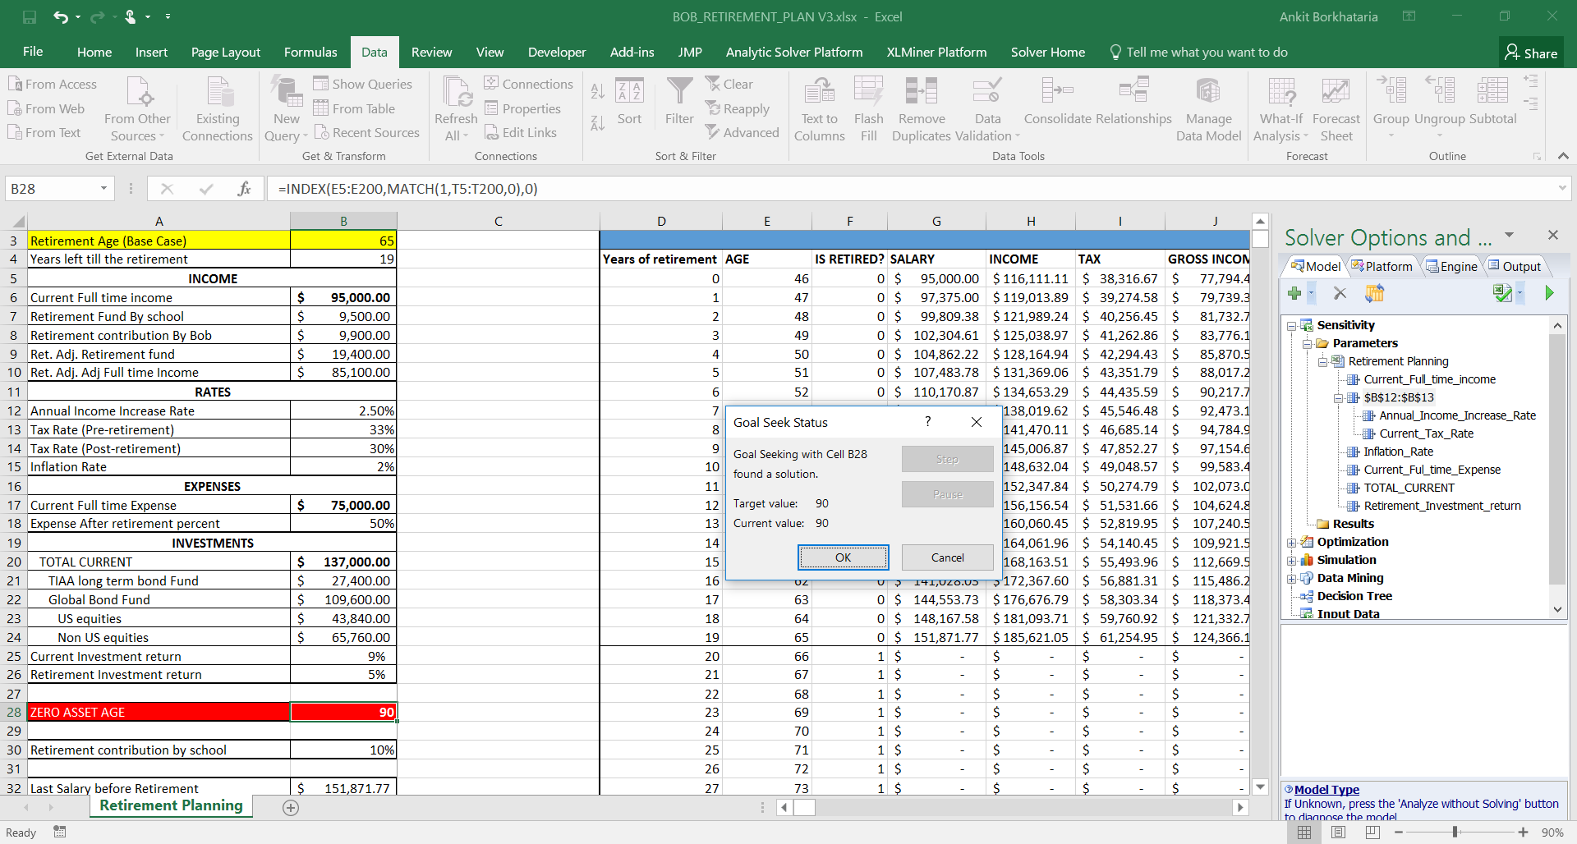

1. **How do Bob’s *zero-asset age* vary when both pre- and post-retirement investment returns are varied? Provide a chart for each, varying pre-retirement investment between 2% and 15%, and post-retirement return between 1% and 9%. Then, provide a three-dimensional chart where both returns are varied at the same time.**

Ans: Below is the chart of Zero-Asset Age with Pre-investment return.

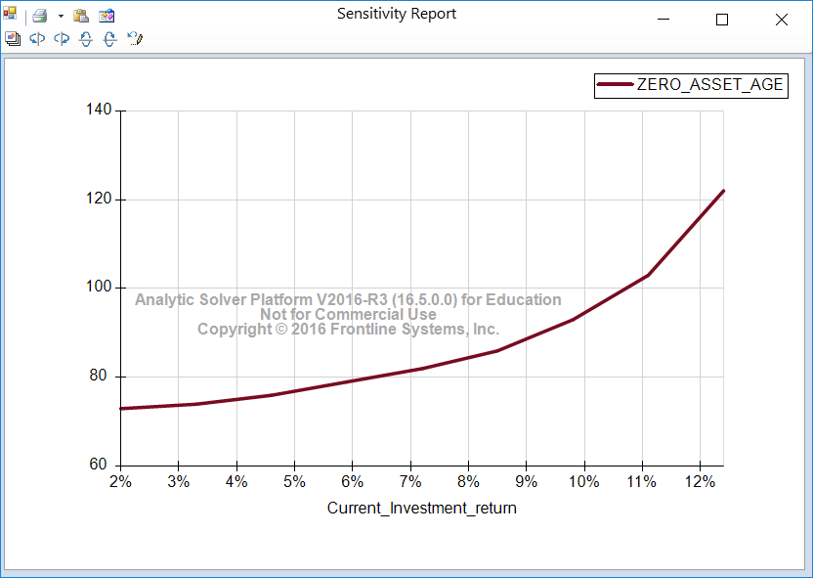

The Zero-Asset Age increases as investment returns before retirement increases.

Below is the chart of Zero-Asset Age with Pre-investment return.

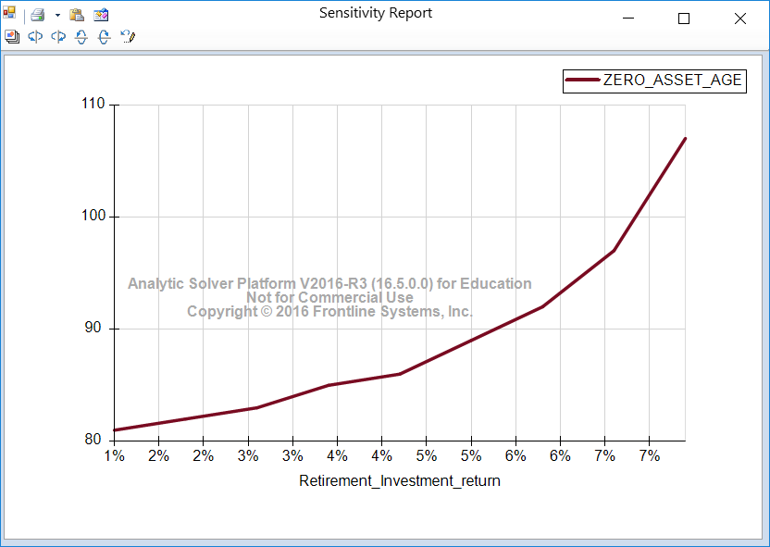

The Zero-Asset Age increases as investment returns after retirement increases.

Below is the three-dimensional chart where both returns are varied.

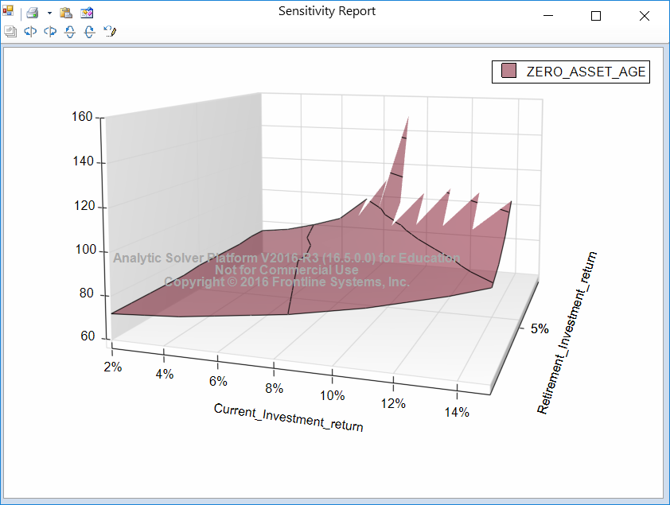

1. **How does Bob’s *zero-asset age* vary with the age at which he retires? Display a chart assuming a retirement age between 60 and 70 years.**

Ans: Conducting the sensitivity analysis, Bob’s Zero-Asset Age increases with his retirement age. Below is the chart where Zero-Asset Age increases when retirement increases from 60 to 70 years.

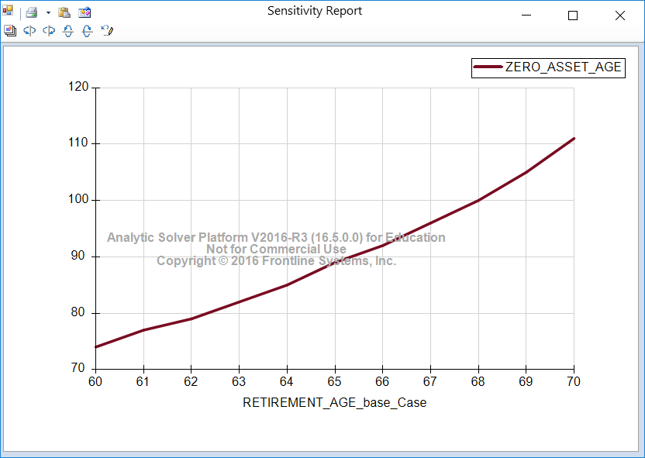

1. **How does Bob’s *zero-asset age* vary with post-retirement tax rate? Vary the tax rate from 20% to 40% in 2% steps.**

Ans: Conducting the sensitivity analysis, Bob’s Zero-Asset Age will decline with increase in Post-Retirement Tax Rate. This is evident from the below graph where Bob’s Zero-Asset Age declines when Post-Retirement Tax Rate increases from 20% to 40%.

